BiophysicsWeak 2026 Biophysics in Ukraine:
Human Energy and Willpower In Science and Education During the Wartime
n
TITLE (Calibri, 18 pt, Bold)
Authors (14 pt; Bold)
Affiliation (11 pt)
e-mail: (11 pt)

Main text (11 pt).
Introduction. It is proved that nitric oxide plays an important role in the adaptation of the organism [1, 2].

Methods.

Results and Discussion.

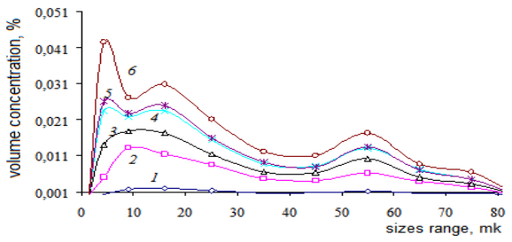
Fig.1. (10 pt) Volume content of particles of different sizes in the aquarium water. 1–initial water; 2–….

Table 1. Concentration of ……..

Conclusions.

Keywords:

References: (10 pt)
- Sagach V.F. (2003) The role of nitric oxide in the regulation of blood circulation. Regulatory function in the body. In: Purines and nitrogen monoxide.Minsk: Tehnoprint.110-3.
- Green D.J., Maiorana A., O'DriscollG., Taylor R.(2004). Effect of exercise training on endothelium-derived nitric oxide function in humans.J Physiol. 561:1-25.

